**Steps followed to upload assignments on github**

1. First, I signed up on [GitHub](https://github.com" \t "_new) to create an account.
2. I downloaded and installed [Git Bash](https://git-scm.com/" \t "_new) to use Git commands on my windows 11.
3. I created a folder to store my assignment files. Then, I navigated to this folder using Git Bash.

**commands**

1. I set up Git to recognize my name and email using the following commands:

**git config --global user.name "nimramaqbool306"**

**git config --global user.email ["f2023266852@umt.edu.pk"](mailto:\"f2023266852@umt.edu.pk\")**

These commands ensure that my commits are linked to my GitHub account.

1. I verified the configuration by typing:

**git config --list**

1. I changed the current directory in Git Bash to the folder where my assignments are stored using:

**cd /path/to/your/folder**

1. I turned my folder into a Git repository by running:

**git init**

This created a .git directory, enabling Git to track changes.

1. Next, I connected my local repository to the GitHub repository by adding a remote URL:

**git remote add origin <https://github.com/nimramaqbool306/se-assignment.git>**

1. I added my assignment files to the staging area using:

**git add .**

The . tells Git to include all files in the current folder.

1. To save the changes, I made a commit with a descriptive message:

**git commit -m "Initial Views"**

1. Finally, I pushed the committed changes to my GitHub repository:

**git push origin master**

1. To ensure the repository was linked correctly, I checked the remote URLs using:

**git remote -v**

**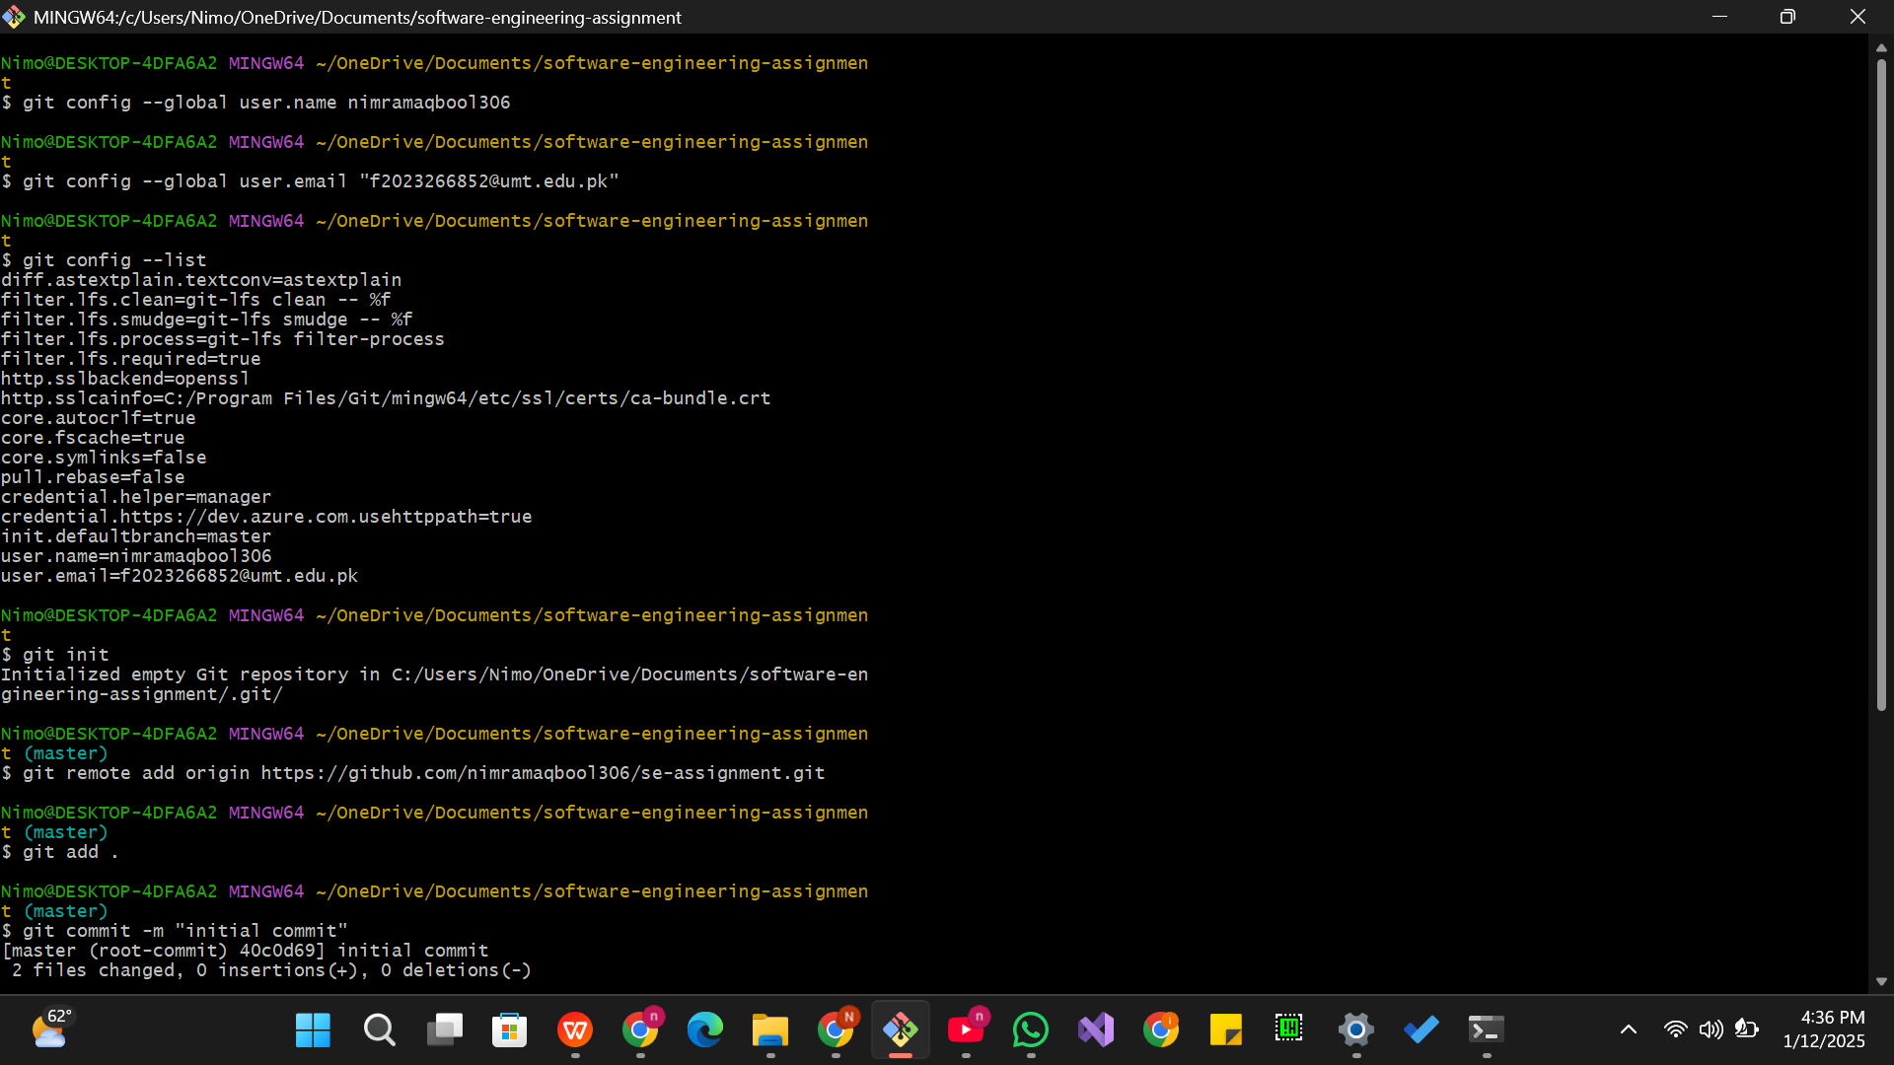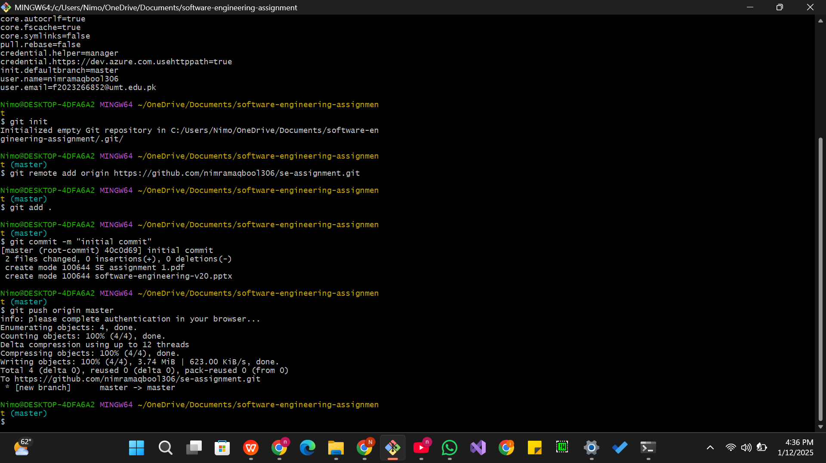**

**Another methods followed:**

**1-**Another method I followed to upload my assignments to GitHub involved using Google Drive. First, I uploaded my assignment files to Google Drive and generated a shareable link for the folder or document. Once I had the link, I included it in the repository I created on GitHub. This allowed me to share the assignments indirectly by providing access to the files stored on Google Drive through the repository. It was a simpler approach that didn’t require using Git Bash for tracking or pushing files directly. Instead, the repository served as a hub to organize and share the links to my assignments.

**2-**one more method method I used to upload my assignments to GitHub was directly through the GitHub website. I started by clicking on the **"Create new repository"** button. In the setup form, I entered the name of my assignment as the repository name and added a description explaining the task. I chose to make the repository public so it would be accessible to anyone. After creating the repository, I used the **"Upload files"** option. I simply dragged and dropped my assignment files into the designated area on the page. Once the files were uploaded, I reviewed the changes, wrote a commit message to describe the upload, and finalized it by clicking the **"Commit changes"** button. This method was also straightforward and didn’t require using any additional tools or commands.